Run script for root bypass

Start server on phone

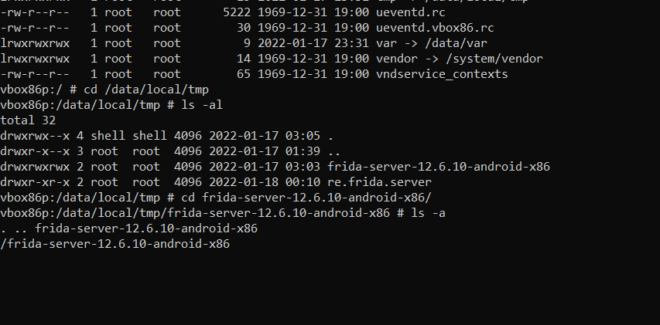

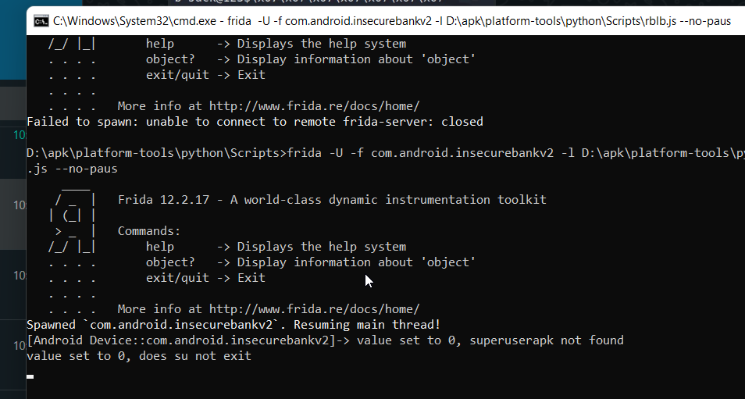**Code to run script**: frida -U -f com.android.insecurebankv2 -l D:\apk\platform-tools\python\Scripts\rblb.js --no-paus

